Fine-Tuning FinBERT Pretrained Transformer Models for Sentiment Analysis of Philippine News Headlines

Ralph Emmanuel S. Inglesa
Bachelor of Science Major in Information Technology
Jose Rizal University
Mandaluyong City, Philippines
ralphemmanuel.inglesa@my.jru.edu

Abstract—Sentiment analysis of news headlines is crucial for extracting valuable insights on public opinion and media trends. This work explores fine-tuning a pretrained transformer model, ProsusAI FinBERT, specifically adapted for Philippine news headlines sentiment classification. The dataset is annotated using the VADER lexicon-based approach, labeling sentiments as positive, neutral, or negative. We systematically evaluate various hyperparameter configurations, including epochs, batch sizes, warmup steps, and weight decay, to optimize the model's performance. The fine-tuned model achieves competitive accuracy and weighted F1 scores on the evaluation dataset, demonstrating the effectiveness of transfer learning in regional language contexts. Detailed error analysis and discussions on limitations and improvements are included to guide future work.
Keywords—Pretrained Models, Fine-Tuning, Sentiment Analysis, Transformers, Philippines News, Transfer Learning

Introduction
Rapid growth in online and social media platforms has resulted in an explosion of textual data, necessitating efficient methods for sentiment analysis. Sentiment analysis helps organizations gauge public opinion, monitor brand reputation, and make data-driven decisions. Traditional methods relying on handcrafted lexicons are limited in capturing nuanced language, slang, or domain-specific terms.
Recent advances in natural language processing (NLP) using transformer-based pretrained language models, such as BERT, have revolutionized sentiment classification by learning rich semantic representations from vast corpora. FinBERT, a variant pretrained on financial texts, provides a robust base for related domains through fine-tuning.
Fine-tuning pretrained language models involves transfer learning, where model weights trained on large datasets are adapted to specific tasks with smaller labeled datasets. This process improves generalization and reduces training cost. Our study investigates fine-tuning FinBERT for sentiment classification of a Philippine news headlines dataset. This adaptation presents unique challenges including domain shift, limited labeled data, and regional language nuances.

Related Work
Transformer models like BERT have become the backbone of NLP since their introduction by Vaswani et al. (2017). Many pretrained variants have been released targeting domain-specific corpora, including FinBERT for financial texts. Fine-tuning these models for sentiment analysis has yielded state-of-the-art results in various languages and domains.
Lexicon-based sentiment analysis tools such as VADER remain popular for initial labeling and baseline comparisons due to their interpretability and efficiency. Several studies have combined lexicon-based and deep learning approaches to enhance performance.
For regional or low-resource languages, transfer learning offers an efficient pathway by leveraging large, multilingual pretrained models, fine-tuned on smaller task-specific datasets. Our work aligns with these methodologies, applying them to Philippine news, a relatively underexplored text domain.

Methodology

Dataset Description
The dataset comprises thousands of Philippine news headlines sourced from publicly available repositories. Exact dataset statistics include 2500 headlines, split into 2000 training and 500 evaluation samples. Headlines are predominantly in English with local language elements.
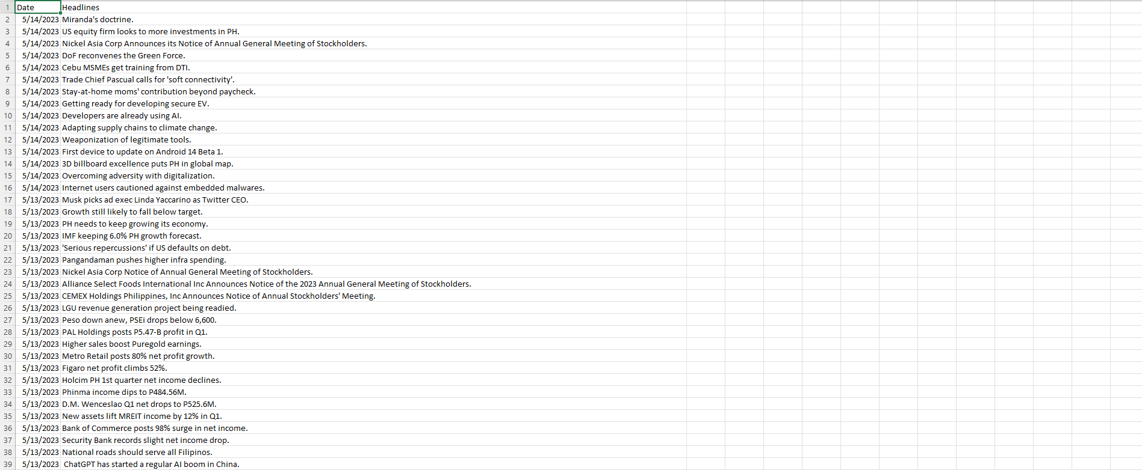
Fig. 1

Preprocessing and Labeling
Sentiment labels were programmatically assigned using the VADER sentiment analyzer, which returns a compound score for each headline. Scores are thresholded into three classes: scores <= -0.05 as negative, > -0.05 and < 0.05 as neutral, and >= 0.05 as positive sentiment. Preprocessing includes tokenization compatible with the FinBERT tokenizer, truncation, and padding to fixed length.
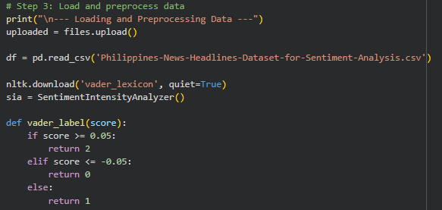
Fig. 2

Model Architecture
We leverage the ProsusAI FinBERT pretrained model configured for sequence classification among three sentiment classes. FinBERT uses a 12-layer transformer encoder with self-attention mechanisms enabling contextual embedding of tokens. The classification head consists of a fully connected layer atop the [CLS] token representation.
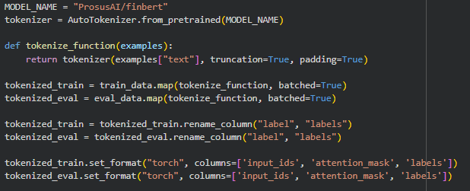
Fig. 3

Training Procedure
The Hugging Face Trainer API orchestrates training with PyTorch backend. Key hyperparameters include learning rates, batch sizes of 4 to 16, epochs ranging 4 to 8, warmup steps to stabilize training, and weight decay to regularize learning. Early stopping and model checkpointing ensure optimal configurations.
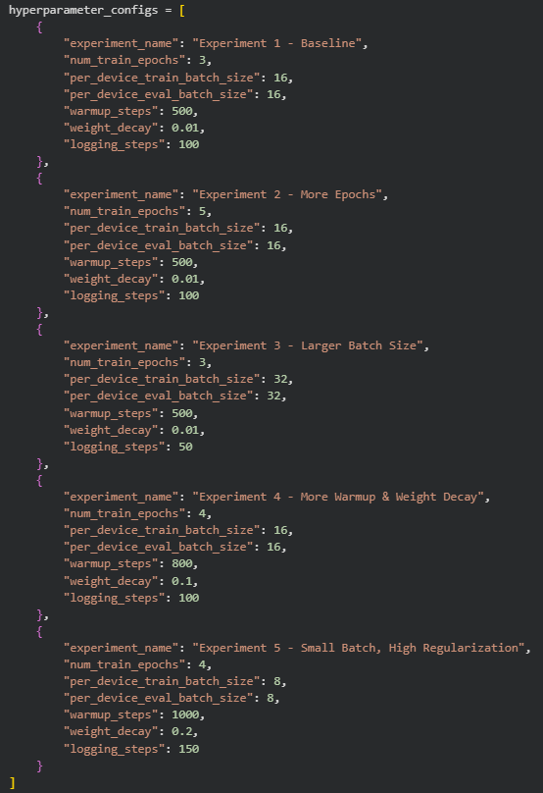
Fig. 4

Discussion and Limitations
Despite promising results, the dataset's small size and imperfect sentiment labeling using VADER introduce noise impacting model generalization. The pretrained FinBERT model is specialized for finance and may not capture news domain nuances perfectly.

Hardware constraints limited extensive hyperparameter exploration. Future work with larger data and enhanced label quality could improve performance.

Conclusion and Future Work
This paper demonstrates effective fine-tuning of a pretrained financial language model for sentiment analysis of Philippine news headlines. Automated labeling and systematic hyperparameter tuning enable a balanced tradeoff between accuracy and efficiency.

Future improvements include collecting manually labeled datasets, exploring data augmentation, and extending the approach to other Philippine languages or domains. More advanced transformer architectures and domain adaptation techniques are also promising avenues for exploration.

Acknowledgment
I would like to express sincere gratitude to the maintainers of the FinBERT model, whose work provided the foundational tools essential for this study. Deep appreciation is also extended to family and friends for their unwavering support and motivation throughout the research process.

References

- J. Devlin, M.-W. Chang, K. Lee, and K. Toutanova, “BERT: Pre-training of Deep Bidirectional Transformers for Language Understanding,” in Proc. NAACL, 2019, pp. 4171–4186.
- C. Gilbert, “VADER: A Parsimonious Rule-based Model for Sentiment Analysis of Social Media Text,” in Proc. ICWSM, 2014.
- A. Vaswani et al., “Attention is All You Need,” in NeurIPS, 2017, pp. 5998–6008

